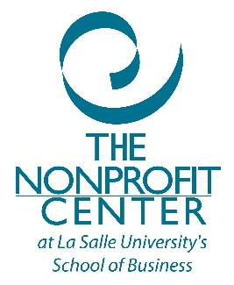

Just in Time Consulting
In order to provide capacity building support to organizations, Pottstown Area Health and Wellness Foundation through the The Nonprofit Center at LaSalle University, is making available to organizations “just in time” help. This Just-in-Time help, provided only when pre-approved by the Pottstown Area Health and Wellness Foundation, would be available by phone to an individual or group who/which want additional information on, and/or help with, a specific problem with which their organization is struggling. Just-in-Time help is not consulting work, but rather help through an expert consultant that is there to assist with a very specific question or issue. There would be a set number of hours available for an organization to access.

Questions in these areas can be addressed:
- Best practices for your board of directors
- Bylaws, policies and procedures
- Board meetings
- Board development and orientation
- Fundraising
- Media relations, marketing, communications, social media best practices
- Human resources fundamentals (exclusive of legal issues)
- Financial management/policies/procedures

Contact the Pottstown Area Health and Wellness Foundation for additional information

