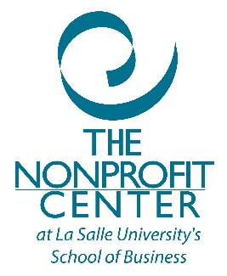

Expert Connections
How many times did you wish you had access to a nonprofit expert who could answer your questions and give advice in a specific area of management and operations? Questions about board policies and practices, how to handle a troublesome board member or problem employee, clarifying temporarily restricted vs. permanently restricted funds, best approaches to budget development, what is the best way to develop a budget, what you need to know before starting a corporate sponsorship program – the topics are as diverse as the sector itself.

And that’s why we created “Expert Connections,” a support package that gives you five hours of annual access to consultant expertise via telephone or email when you “just have a question.”

We’ve made it simple to have access, usually within 48 hours, to an expert. Based on what nonprofits have told us they need, we’ve packaged five hours of expert advice to utilize over the 12-month period, giving you support for all your questions throughout the year. Each time you call for assistance, you’ll be matched with a Nonprofit Center specialist to address your question and help resolve your dilemma. Your calls will be charged in 30- minute increments and for best use of this service, we suggest that you use this help for issues that can be addressed in under 90 minutes, at most.

Sample issues we help with:
- Strategic planning (including evaluation readiness, guidelines, etc.)
- Best practices for your board of directors
- Bylaws, policies and procedures
- Board meetings
- Board development and orientation
- Fundraising
- Media relations, marketing, communications, social media best practices
- Human resources fundamentals (exclusive of legal issues)
- Financial management/policies/procedures

Contact the Pottstown Area Health and Wellness Foundation for additional information

